- Launch one EC2 using Amazon Linux 2 image and add a script in user data to install Apache.

Objective : Launch an EC2 instance using Amazon Linux 2 and
automatically install Apache web server using User Data script at
boot time
Outcome: A running EC2 instance serving a webpage via Apache
on port 80, fully configured without manual SSH intervention
Steps:
1. Go to AWS Console → EC2 → Launch Instance
2. Name: Apache-Server
3. AMI: Select Amazon Linux 2 AMI (HVM)
4. Instance type: t2.micro (free tier)
5. Key pair: Create or select existing
6. Security Group: Allow HTTP (port 80) and SSH (port 22)
7. Scroll to Advanced Details → User Data, paste this script

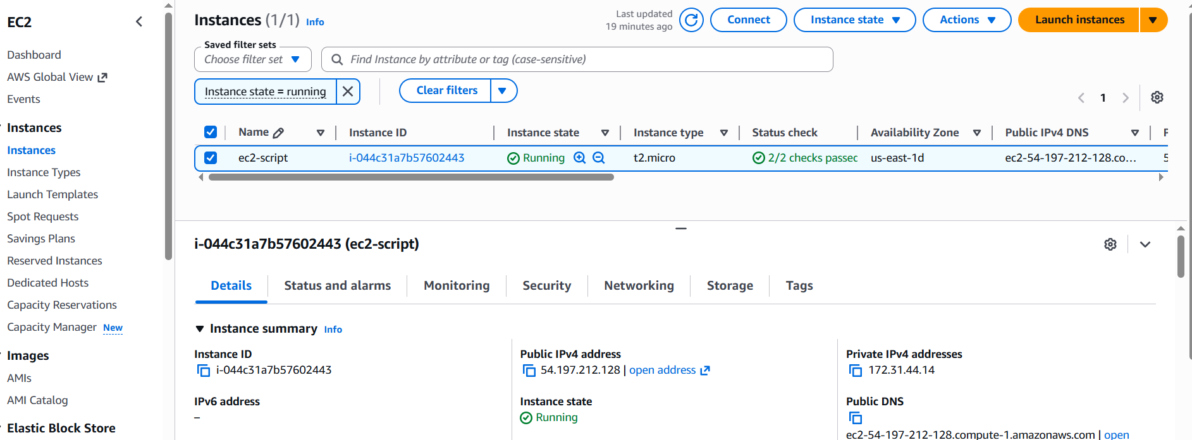

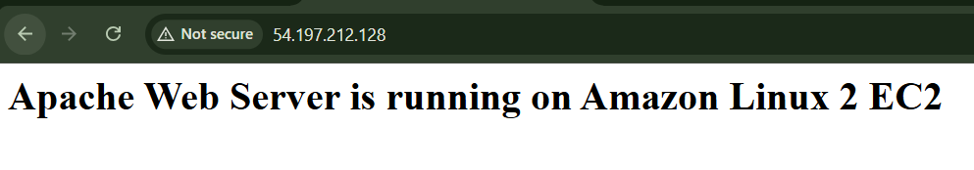

- Launch one EC2 using Ubuntu image and add a script in user data to install Nginx.

1. Go to EC2 → Launch Instance
2. Name: Ubuntu-Server
3. AMI: Select Ubuntu Server 22.04 LTS
4. Instance type: t2.micro
5. Key pair: Select the same key pair (you'll need it for Task 5)
6. Security Group: Allow HTTP (port 80) and SSH (port 22)
7. User Data

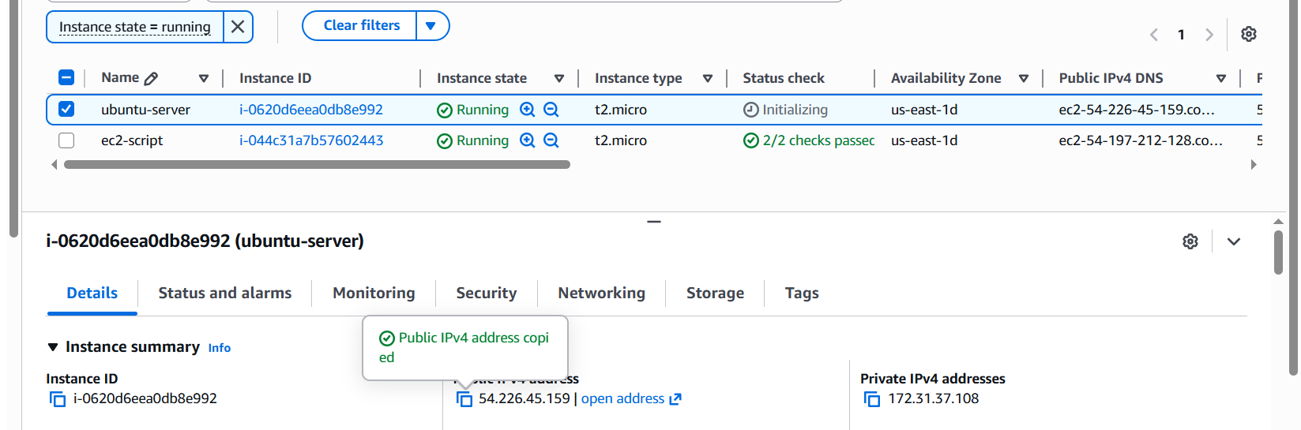

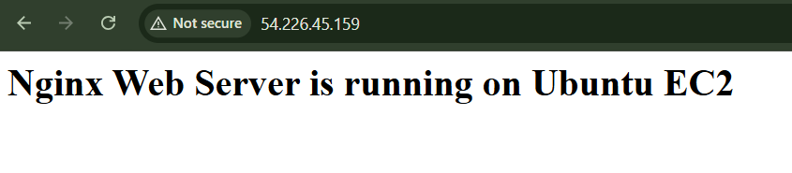

- Launch one Windows server and install Tomcat on Windows.

Launch Windows Server EC2
- Go to AWS Console
- Search EC2
- Click Launch instance
- Name: Windows-Tomcat-Server
- AMI: Select Microsoft Windows Server 2019/2022 Base
- Instance type: t2.micro or t3.micro
- Key pair: Select existing key pair or create new one
- Network:
  - Select your VPC
  - Select public subnet
  - Enable Auto-assign public IP
- Security Group inbound rules:
  - RDP → Port 3389 → Your IP
  - HTTP → Port 80 → Anywhere
  - Custom TCP → Port 8080 → Anywhere or Your IP
- Click Launch instance
Connect to Windows Server
- Select your Windows EC2 instance
- Click Connect
- Go to RDP client
- Click Get password
- Upload your .pem key
- Click Decrypt password
- Download the Remote Desktop file
- Open it
- Username: Administrator
- Password: use decrypted password
- Click Connect
Install Java JDK
Tomcat needs Java.
- Open browser inside Windows Server
- Download JDK 17 from Oracle or Eclipse Temurin
- Install it with default options
- After installation, open Command Prompt
- Check Java:
java -version
If you see Java version, Java is installed correctly.
Set Java Environment Variable
- Search Environment Variables
- Open Edit the system environment variables
- Click Environment Variables
- Under System variables, click New
- Add:
Variable name: JAVA_HOME
Variable value: C:\Program Files\Java\jdk-17
The exact path may differ. Check your Java installation folder.
- Select Path
- Click Edit
- Click New
- Add:
%JAVA_HOME%\bin
- Click OK on all windows
- Open new Command Prompt and test:
echo %JAVA_HOME%
java -version
Download Apache Tomcat
Use the official Apache Tomcat website only. As of now, Apache lists current Tomcat branches like Tomcat 9, Tomcat 10.1, and Tomcat 11. Tomcat 9 is commonly used for older Java EE apps, while Tomcat 10/11 use newer Jakarta EE packages.
For simple practice, use Tomcat 9.
- Go to Apache Tomcat official download page
- Select Tomcat 9
- Under Binary Distributions
- Download:
32-bit/64-bit Windows Service Installer
Install Tomcat
- Run the downloaded Tomcat installer
- Click Next
- Choose components:
  - Tomcat
  - Start Menu Items
  - Manager
  - Host Manager
- Set port:
HTTP/1.1 Connector Port: 8080
- Set username/password for Tomcat Manager, for example:
Username: admin
Password: Admin@12345
Roles: manager-gui,admin-gui
- Select Java path if asked
- Complete installation
- Start Tomcat service
Check Tomcat in Browser
Inside Windows Server browser, open:
http://localhost:8080
You should see the Apache Tomcat welcome page.
From your local laptop browser, open:
http://<Windows-Server-Public-IP>:8080
Example:
http://3.15.25.100:8080
If Tomcat Is Not Opening
Check these three things:

Security Group
Inbound rule must have:
Type: Custom TCP
Port: 8080
Source: 0.0.0.0/0
For safer access, use Your IP instead of anywhere.

Windows Firewall
Inside Windows Server:
- Search Windows Defender Firewall
- Click Advanced settings
- Click Inbound Rules
- Click New Rule
- Select Port
- TCP → Specific port:
8080
- Allow connection
- Apply to all profiles
- Name it:
Tomcat 8080

Tomcat Service
Open Services and check:
Apache Tomcat
Status should be Running

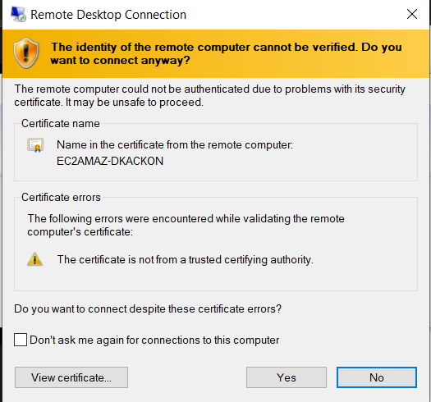
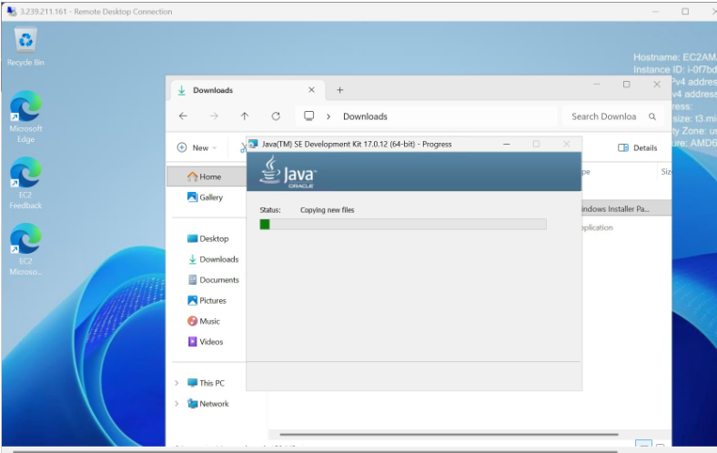

- Take a snapshot of the instance created in Task 1.

Purpose : The purpose of taking a snapshot is to create a backup of the EC2 instance volume. It helps in restoring the server data, recovering from failures, and creating a new volume or instance from the saved state
I created a snapshot of the EBS volume attached to the Task 1 Amazon Linux 2 Apache EC2 instance. The snapshot was verified under EC2 > Elastic Block Store > Snapshots.

- Go to AWS Console.
- Open EC2 service.
- Click Instances.
- Select your Task 1 Amazon Linux 2 Apache instance.
- Scroll down and click Storage tab.
- Find the Volume ID under root volume.
- Click the Volume ID.
- It will open the Volumes page.
- Select that volume.
- Click Actions.
- Click Create snapshot.
- Enter description:
Snapshot of Task 1 Amazon Linux 2 Apache EC2 instance
- Click Create snapshot.
- Go to left menu → Elastic Block Store → Snapshots.
- Check snapshot status.
- Wait until status changes from Pending to Completed

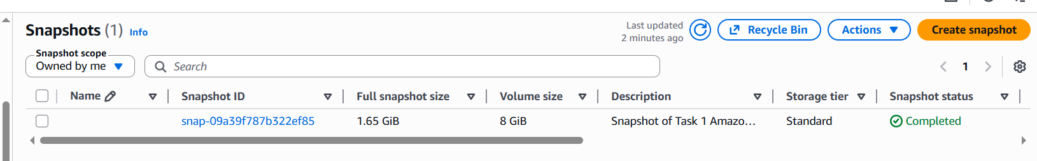
.

- Launch any EC2 using the spot purchasing option.
Purpose: The purpose of creating Spot Instances is to run EC2 servers at a lower cost compared to normal On-Demand instances
AWS has extra unused servers. Instead of keeping them idle, AWS gives them as Spot Instances at a discounted price
Launch https://aws.amazon.com/ on browser.
• Sign in as a root user with the email address and password.
• Search for ec2 service.
• Click on launch instance.
• Give any name to the instance.
• Under AMI section, select quick start option
• Select ubuntu as OS.
• Ubuntu server 26.04 lts
• Select t3.micro instance type.
• Select a key pair or create new key pair if not available.
• Select create security group under network settings.
• Enter security group name and give any description.
• Click on add security group rule.
• Select type:ssh, protocol:TCP, port:22 and source type: anywhere
• Navigate to advanced details section.
• Navigate to purchasing option section.
• Select spot instances option.
• Click on launch instance.
• Navigate to instance page
• Notice that the spot-instance is running

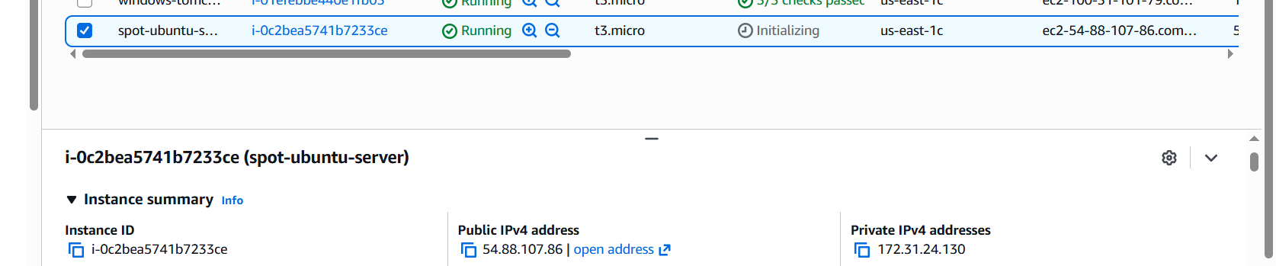

- Enable termination policy on the EC2 created in Task 2.

Purpose : By enabling termination protection, you are making sure the instance cannot be accidentally terminated from the AWS Console

Select ubuntu-nginx instance from instance page.
• Click on actions button.
• Select instance settings.
• Click on change termination protection.
• Notice that the change protection popup is displayed.
• Select the check box to enable termination protection.
• Click on save button.
• Navigate to ubuntu-nginx instance page.
• Scroll down to details section.
• Observe that termination protection is enabled

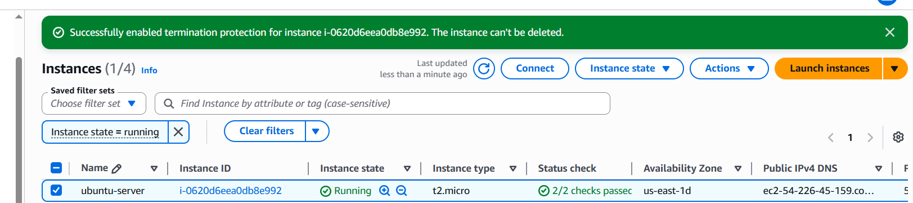

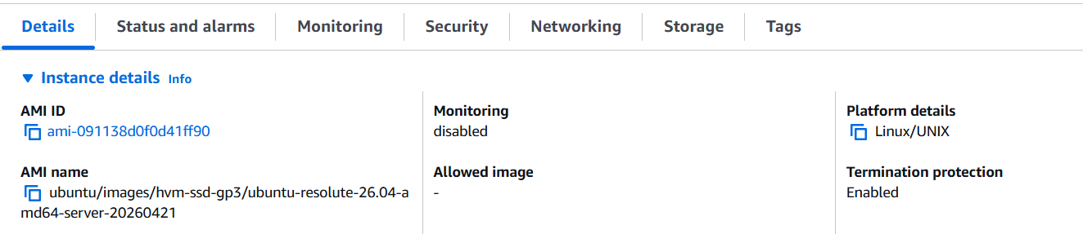

- Launch one EC2 using AWS CLI
Purpose : In real DevOps work, we don’t always create servers manually from the console. We use commands, scripts, Terraform, Jenkins, Ansible, etc. This task is the basic starting point for automation.

Launch https://aws.amazon.com/ on browser.
• Sign in as a root user with the email address and password.
• Search for IAM in search bar.
• Select IAM.
• Click on IAM users under access management.
• Click on create user.
• User name is listed under IAM users list page.
• Select the created user.
• Click on create access key.
• Select CLI as usecase.
• Click next
• Click on create access key.
• Notice that the access key is created and user is navigated to
retrieve access key page.
• Now open git bash on your local machine.
• Aws - - version to check the aws version.
• Mention aws configure command.
• Enter access key and secret key, location: us-east-1 and output
format: json.
aws ec2 run-instances \
--image-id ami-091138d0f0d41ff90 \
--count 1 \
--instance-type t3.micro \
--key-name bashscript \
--security-group-ids sg-0cf5cf3242f965b46 \
--subnet-id subnet-0f497ed129695f4b9• aws ec2 describe-instances --output table
• navigate back aws ec2 instance page.
• Observe that instance is running

